NETWORK FUNDAMENTALS AND BUILDING NETWORKS

Assignment day 4

TASK1: Given a network address of 192.168.10.0/24, divide it into 4 equal subnets and write down the subnet mask, network address, and broadcast address for each subnet.
- Original Network: 192.168.10.0/24
- Required Subnets: 4
- Borrowed Bits = 2
- Subnet Mask = 255.255.255.192
- Hosts per Subnet = 62 usable hosts
Subnet | Network Address | Subnet Mask | Broadcast Address
Subnet 1 | 192.168.10.0 | 255.255.255.192 (/26) | 192.168.10.63
Subnet 2 | 192.168.10.64 | 255.255.255.192 (/26) | 192.168.10.127
Subnet 3 | 192.168.10.128 | 255.255.255.192 (/26) | 192.168.10.191
Subnet 4 | 192.168.10.192 | 255.255.255.192 (/26) | 192.168.10.255

TASK2: For one of the subnets you created, assign valid IP addresses to 5 devices (such as a router, two laptops, a printer, and a mobile) and list which IP goes to which device.<br><br><em><strong>Hint:</strong> Make sure not to use the network or broadcast address for any device.</em>
Selected Subnet
Subnet 1: 192.168.10.0/26
Usable IP Range: 192.168.10.1 – 192.168.10.62
Device | Assigned IP Address
Router | 192.168.10.1
Laptop 1 | 192.168.10.2
Laptop 2 | 192.168.10.3
Printer | 192.168.10.4
Mobile Phone | 192.168.10.5

TASK3: Draw a simple diagram (hand-drawn or digital) showing your subnet plan: label each subnet, the range of IPs, and where each device is connected.
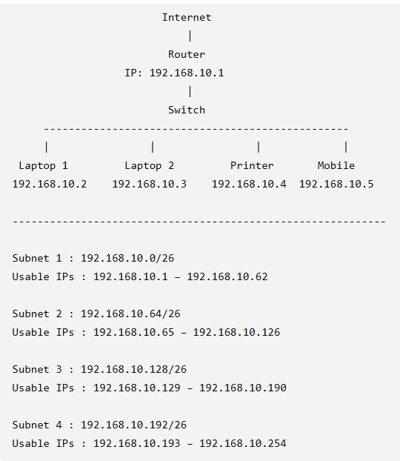

TASK4: Document step-by-step how you calculated the subnet mask, number of hosts per subnet, and assigned IP addresses for your plan, as if you are explaining it to a friend who is new to subnetting.
Steps Performed
Step 1: Started with the network 192.168.10.0/24.
Step 2: I needed 4 subnets, so I borrowed 2 bits from the host portion because 2² = 4 subnets.
Step 3: The subnet mask changed from /24 to /26, which is 255.255.255.192.
Step 4: Each subnet contains 64 IP addresses, but 2 addresses (network and broadcast) cannot be used. Therefore, each subnet has 62 usable host addresses.
Step 5: I listed the four subnet network addresses and broadcast addresses by increasing the network address by 64 each time:
- 192.168.10.0
- 192.168.10.64
- 192.168.10.128
- 192.168.10.192
Step 6: I selected the first subnet and assigned valid IP addresses to the router, laptops, printer, and mobile phone. I made sure not to use the network address or broadcast address.

